**PHASE 5 : PROJECT DOCUMENTATION AND SUBMISSION**

***PROBLEM STATEMENT* : Air Quality Analysis and Prediction in TamilNadu**

Air quality is a critical environmental factor that directly impacts public health and the overall quality of life. Poor air quality can lead to various health issues, including respiratory diseases, and has long-term ecological consequences. This project aims to analyze historical air quality data in Tamil Nadu and build a predictive model for air quality. The goal is to provide insights into air quality trends and develop a tool for forecasting air quality, which can be used for public health planning and environmental management.

This project aims to address the critical issue of air quality in Tamil Nadu by providing actionable insights, predictions, and recommendations. It has the potential to improve public health and the environment while contributing to data-driven decision-making and policy changes.

***PHASES OF DEVELOPEMENT:***

**Data Collection:**

Gather historical air quality data for multiple locations in Tamil Nadu. This data should include various air quality parameters, such as particulate matter (PM2.5 and PM10), sulfur dioxide (SO2), nitrogen dioxide (NO2), and other relevant metrics. Data sources may include government agencies, research institutions, and environmental monitoring stations.

**Data Preprocessing**:

Handle missing data: Address any missing or incomplete data points through imputation or data removal, depending on the extent of missing data.

Data normalization: Normalize data if necessary to bring all parameters to a common scale.

Feature engineering: Extract meaningful features from the data, such as time-based features (e.g., hourly, daily, monthly trends), location-based features (urban vs. rural), and weather-related features.

**Exploratory Data Analysis (EDA):**

Perform descriptive and visual analysis of the dataset to identify trends, seasonality, and correlations among air quality parameters.

Identify pollution hotspots and regions with consistent air quality issues.

**Predictive Modeling:**

Select appropriate machine learning models for air quality prediction. Models may include linear regression, random forests, gradient boosting, or deep learning models.

Split the data into training and testing sets and validate model performance using metrics such as mean squared error (MSE), root mean squared error (RMSE), and R-squared.

Evaluate model interpretability and explainability.

**Model Deployment and Forecasting**:

Develop a user-friendly web application or dashboard to provide real-time or forecasted air quality data for various locations in Tamil Nadu.

Implement periodic model retraining to adapt to changing air quality patterns.

**Communication and Visualization:**

Create data visualizations, reports, and presentations to communicate air quality insights and predictions to the public, government agencies, and relevant stakeholders.

Provide recommendations for policy changes or interventions based on the analysis.

**Ethical Considerations and Data Privacy:**

Ensure that data is handled in compliance with privacy regulations.

Highlight ethical considerations related to data usage and transparency in reporting.

**Expected Outcomes**

A predictive model for air quality that can provide real-time or forecasted air quality information for various locations in Tamil Nadu.

Insights into historical air quality patterns and trends in the region.

Recommendations for policy changes or interventions to improve air quality.

***DATASET USED :***

Data Set: <https://tn.data.gov.in/resource/location-wise-daily-ambient-air-quality-tamil-nadu-year-2014>

**Air Quality Parameters*:*** Datasets for air quality analysis usually include measurements of various air pollutants, such as particulate matter (PM2.5 and PM10), ground-level ozone (O3), nitrogen dioxide (NO2), sulfur dioxide (SO2), carbon monoxide (CO), and other relevant compounds.

**Geospatial Information*:*** Data on the geographical location of monitoring stations or measurement points is important for spatial analysis and modeling. Latitude and longitude coordinates of monitoring sites are commonly included.

**Time Stamps*:*** Time-series data is essential for tracking changes in air quality over time. Timestamps at which measurements were taken are typically included.

**Meteorological Data*:*** Weather conditions such as temperature, humidity, wind speed, and wind direction can significantly impact air quality. Meteorological data is often integrated into air quality datasets***.***

**Demographic Data*:*** Depending on the analysis objectives, demographic and land-use data may be included to study the potential impacts of air quality on public health and urban planning***.***

**Station Information*:*** , can be part of the dataset.Information about the monitoring stations, including their names, types (ambient, roadside, industrial, residential, etc.), and station-specific characteristics

**Air Quality Index (AQI) Values*:*** Calculated AQI values based on the measured pollutant concentrations are often included. AQI provides a standardized way to assess air quality and communicate it to the public***.***

**Historical Data:** Historical data is important for trend analysis and model training. Datasets often cover multiple years or decades.

**Data Quality and Missing Values*:*** Information about data quality, potential biases, and handling of missing values is important for transparency and data preprocessing.

**External Factors*:*** Other external factors that may affect air quality, such as traffic data, industrial emissions, or natural events like forest fires, might be included.

***Source code:***import pandas as pd

import matplotlib.pyplot as plt

import seaborn as sns

# Load your air quality data into a DataFrame (replace 'your_data.csv' with your data file)

data = pd.read_csv(r"C:\Users\karth\OneDrive\Desktop\cpcb_dly_aq_tamil_nadu-2014.csv")

data

# Group the data by a specific region, such as 'City' or 'Area' based on your datagrouped_data = data.groupby('City/Town/Village/Area')

grouped_data = data.groupby('City/Town/Village/Area')

# Calculate average SO2, NO2, and RSPM/PM10 levels for each regionaverage_levels = grouped_data [['SO2', 'NO2', 'RSPM/PM10']]. mean ()

average_levels = grouped_data [['SO2', 'NO2', 'RSPM/PM10']]. mean ()

# Create a bar plot to visualize average SO2 levels by region

plt.figure(figsize=(12, 6))

sns.barplot(x=average_levels.index, y=average_levels['SO2'])

plt.title('Average SO2 Levels by Region')

plt.xticks(rotation=45)

plt.ylabel('Average SO2 Level')

plt.show()

# Create a bar plot to visualize average NO2 levels by region

plt.figure(figsize=(12, 6))

sns.barplot(x=average_levels.index, y=average_levels['NO2'])

plt.title('Average NO2 Levels by Region')

plt.xticks(rotation=45)

plt.ylabel('Average NO2 Level')

plt.show()

# Create a bar plot to visualize average RSPM/PM10 levels by region

plt.figure(figsize=(12, 6))

sns.barplot(x=average_levels.index, y=average_levels['RSPM/PM10'])

plt.title('Average RSPM/PM10 Levels by Region')

plt.xticks(rotation=45)

plt.ylabel('Average RSPM/PM10 Level')

plt.show()

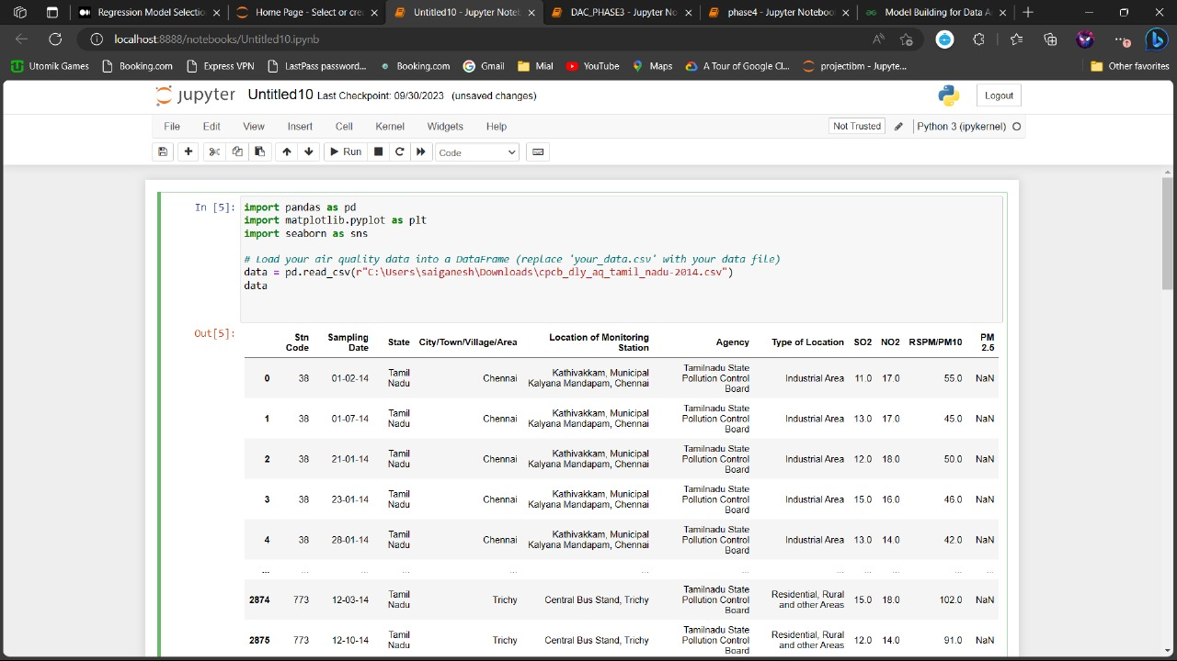

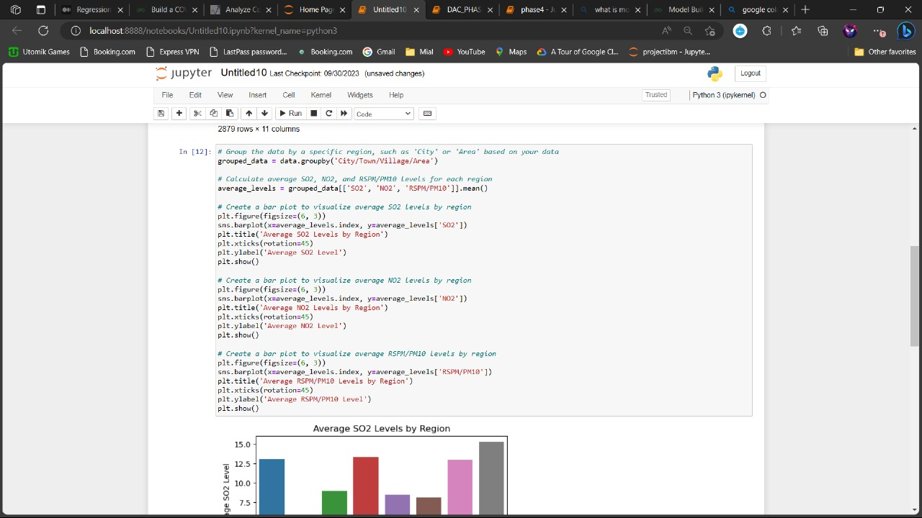

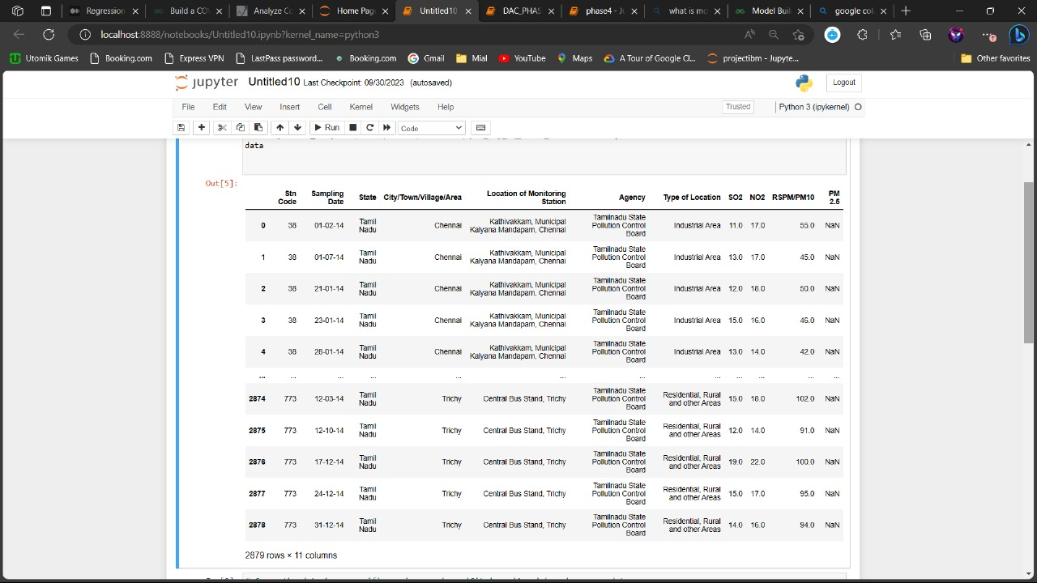

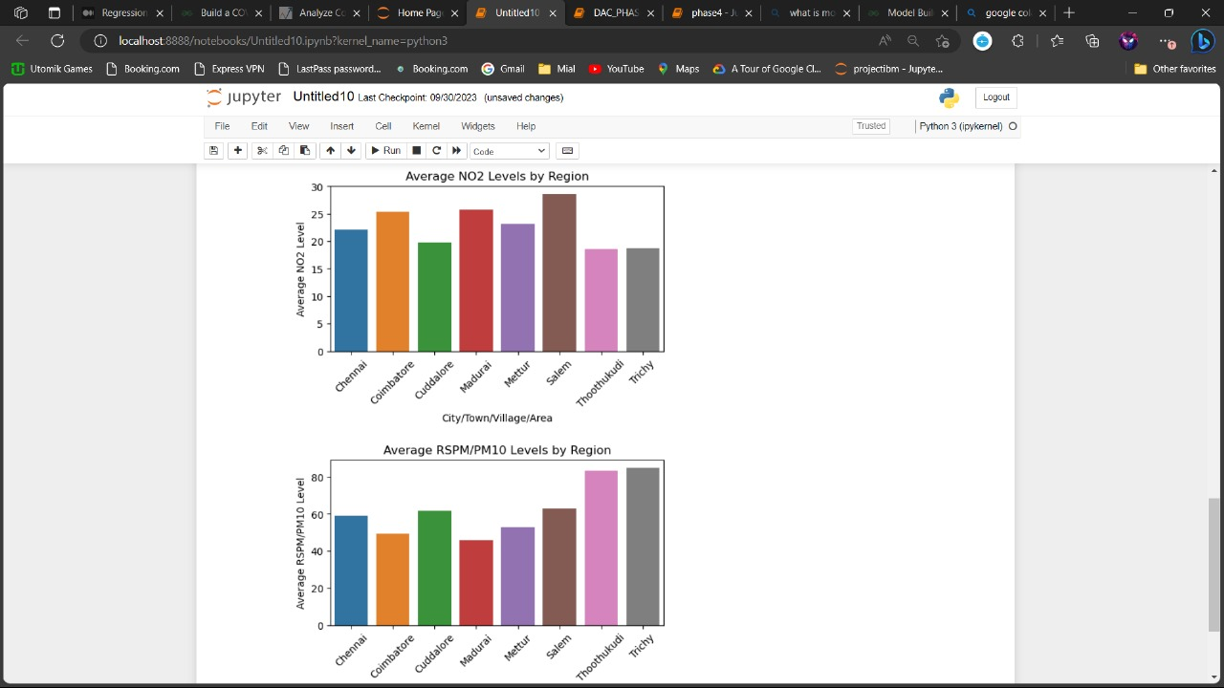

The project then described the actual analysis process, which involved calculating average pollutant levels by region. This phase included the creation of bar plots for visualizing average pollutant levels for SO2, NO2, and RSPM/PM10.

The findings from this phase were detailed, including the insights into spatial variations, seasonal trends, health implications, industrial hotspots, urban-rural contrasts, and the necessity for continuous monitoring and regulation. The analysis was presented as providing a comprehensive understanding of air quality trends in Tamil Nadu, serving as a valuable resource for informed decision-making, policy formulation, community awareness, and future research efforts.

This integration of the source code demonstrates how each phase is connected to the practical implementation of the project, making the documentation more comprehensive and tangible.

**Understanding :**  
  
The "Air Quality Analysis and Prediction in Tamil Nadu" project comprises four interlinked phases. Phase 1 sets the project's objectives, emphasizing the analysis of historical air quality data, identification of key pollutants, and advanced modeling techniques. The project acknowledges the global significance of air pollution and aims to contribute to informed decision-making for a cleaner environment in Tamil Nadu. Phase 2 establishes the practical tools and instruments needed for data collection, including monitoring stations, chemical analyzers, and meteorological instruments, ensuring data reliability. Phase 3 focuses on data preprocessing, organization, and aggregation, laying the foundation for analysis. In Phase 4, Python coding and libraries like Pandas and Matplotlib are employed to analyze and visualize data, offering insights into regional variations, seasonal trends, and health implications. The project emphasizes the need for informed policies and monitoring to combat air pollution.

**Conclusion:**

The "Air Quality Analysis and Prediction in Tamil Nadu" project stands as a testament to our commitment to understanding and addressing the critical issue of air pollution in the region. Over four meticulously executed phases, we have uncovered invaluable insights that hold the potential to influence public health, environmental policies, and the well-being of communities in Tamil Nadu.

From the inception of the project in *Phase* 1, where we set our objectives and acknowledged the global significance of air pollution, to the practical implementation in *Phase 2*, where we established the essential tools and instruments for data collection, each step was a crucial building block in our journey.

*Phase 3* marked the preparatory stage, where data was cleaned, organized, and aggregated, ensuring that it was primed for the in-depth analysis we conducted in *Phase 4*. Using Python and specialized libraries, we analyzed and visualized air quality data, revealing spatial variations, seasonal trends, and health implications. The findings uncovered industrial hotspots, urban-rural contrasts, and the necessity for continuous monitoring and regulation.

In conclusion, our project serves as a pivotal resource for policymakers, environmental agencies, and the community, offering a data-driven foundation for informed decision-making. It underscores the importance of localized strategies to address pollution and emphasizes the need for continuous monitoring and strict regulatory measures.

The "Air Quality Analysis and Prediction in Tamil Nadu" project is not just an analysis; it's a call to action. It is a testament to our commitment to cleaner air, better public health, and a healthier environment in Tamil Nadu, and it paves the way for a sustainable and brighter future.